- 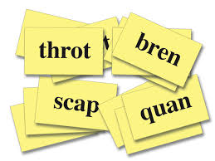 Cards
- Break – 2 minutes
- 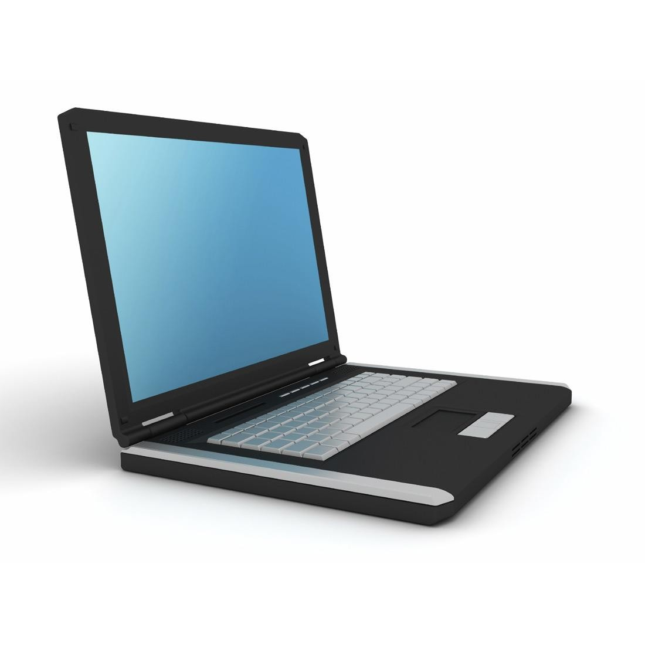 Words (20)
- Break – 2 minutes
- Words (20)
- Break – 2 minutes
- Words (20)
- Break – 2 minutes
- Words (20)
- Break – 2 minutes
- Words (20)
- Finish

